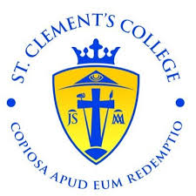
School Calendar for 2025/2026

Staff Return Wednesday 20th August 2025 – Ethos/Planning Day.
School Re-opens Thursday 21st August 2025 - 1st Years only – 9 am to 12.20 pm.
Closed Friday 26th September 2025.
In House Exams 3rd & 6th Year – Mon Oct 20th – Fri Oct 24th 2024
Mid-term Break Mon 27th Oct – Fri 31st 2025. Re-Open Mon Nov 3rd.
Staff Training Tuesday November 4th
Oide Training Thursday December 4th
Closed Monday 8th December 2025.
In House Exams 1st, 2nd & 5th Year – Thurs 11th Dec-Wed17th Dec.
Christmas holidays Closed Mon 22nd Dec 2025 to Fri 2nd Jan 2026. Re-Open Mon 5th Jan.
Closed Monday February 2nd 2026 Bank Holiday.
Pre-Examinations Tuesday February 3rd to Friday 13th February 2026.
Mid-Term Break Monday 16th February – Friday 20th February 2026.
Senior Cycle Training Tuesday February 24th
Closed Monday 16th & Tuesday 17th March 2026 (Bank Holiday).
Easter Holidays Monday 30th March to Fri 10th April -Reopening Mon 13th April.
Closed Monday May 4th 2026 -Bank Holiday.
Summer Exams Monday 25th May – Friday 29th May 2026.
Summer Holidays Friday 29th May 2026 – Last day of Term.
State Examinations Wednesday 3rd June 2026.
Parent Teacher Meetings –Provisional Dates subject to change
Third/ Sixth Year Tuesday 9th December 2025 4.15pm -6.45pm
Second/Fifth Year Monday 26th January 2026 4.15pm - 6.45pm
First/Transition Year Tuesday 10th March 2026 4.15pm - 6.45pm

